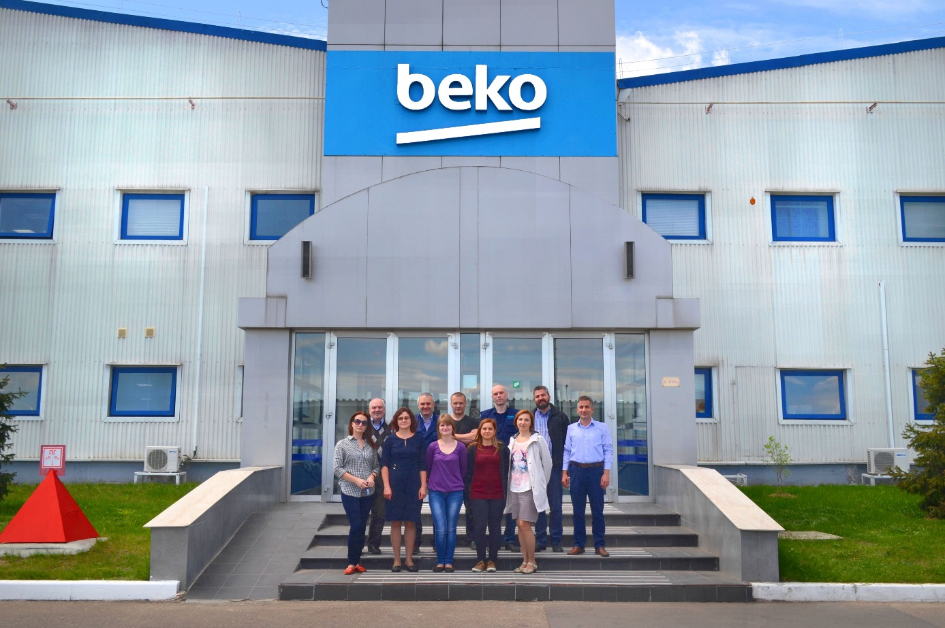

Beko LLC Receives ISO 14064-1 Certificate
Beko LLC issued the Greenhouse Gas Emissions Inventory for 2016 in accordance with the international ISO 14064-1 standard. A 'Verification Certificate' was granted to Beko LLC after the audit made by BSI (British Standards Institution), an independent accreditation body.
Within the context of the studies conducted by Arçelik A.Ş. in line with its 'Respects the Globe, Respected Globally' vision, greenhouse gas emissions from 6 campus areas where the company's 8 domestic manufacturing plants are found, and from Sütlüce campus incorporating the headquarters, have been calculated and verified pursuant to ISO 14064-1 Standard since 2010 and greenhouse gas emissions from Arctic Refrigerator Plant have been calculated and verified since 2015. With the project initiated at the end of 2016, Arçelik A.Ş. Beko LLC Refrigerator and Washing Machine Plant in Russia was also included in the scope of this study.
Supporting the global initiatives about reducing the effects of climate change, Arçelik has been showing an exemplary performance by being awarded at the Carbon Disclosure Project (CDP) -which is regarded as the most prestigious environmental initiative of the world- every year since 2012. In 2014 and 2016, Arçelik got the A performance score, the highest degree of CDP Performance Rating, and became the first Turkish industrial company to enter this list twice.

