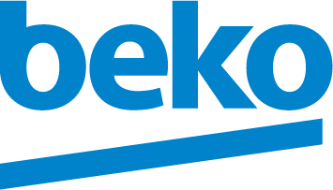

Beko brings the best of Europe to Argentina

Beko introduced its range of laundry products and refrigerators with cutting-edge technology and higher energy saving levels than the market average in Argentina at the recent press meeting in Four Seasons Hotel Buones Aires. Meral Barlas, the ambassador of Turkey in Argentina and Bayram Kaçar, the commercial counsellor as well as 60 press members including lifestyle, technology, economy editors and bloggers attended the event.

The event began with a surprising free-style football show and continued with the opening speech of Ezequiel Devoto, Home Appliances Director at BGH. Devoto said: “The products are the most efficient in the market in their respective categories, and they are introduced in Argentina at a time when energy saving has become one of consumers’ major concerns.”

The event followed by South America Regional Manager, Cem Başaral’s presentation on Beko’s global success. Başaral said: “We decided to enter the Argentina market with a wide, high-quality offering of the best house appliances in the world, now that this country is at a pivotal moment, as we perceive signs of improvement for the business, hoping to see a consolidation and steady projection.”

After the presentation of Juan Manuel Vallori, Beko Business Manager at BGH, and one-to-one product overviews that highlight the hero features of the products, the press members received FC Barcelona uniforms as gifts.

Argentina is the key market in South America region following Brazil with 2.2 billion USD worth MDA 9 market. This week Beko products will gain a place in stores of Garbarino which is the biggest retail in Argentina with 28% market share.

