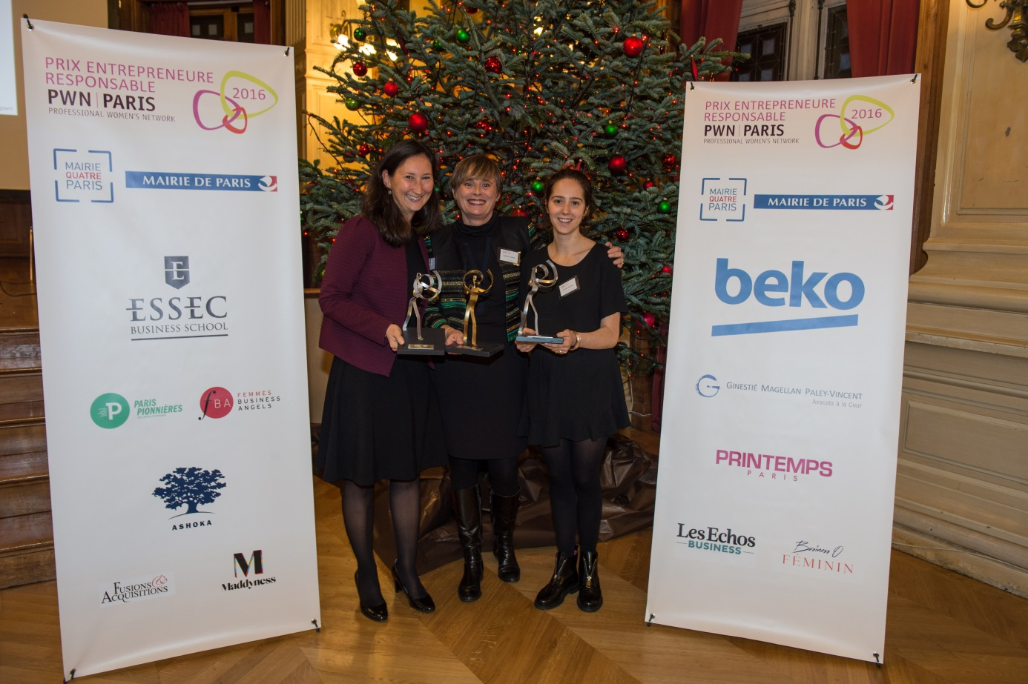
The CSR Action :

Beko France, partner of Professional Women's Network Paris, member of the worldwide network PWN, Global movement of people working towards gender balanced leadership through professional development and international, cross-industry, and in-person networking.

The mission of the association is to promote the professional progress of women and give them the tools, networks and skills they need to assume leadership roles.
PWN Global is present in 26 major cities from France (800 members in Paris), Brazil, Sweden, Turkey and China...with representatives from nearly 90 nationalities.

Beko France have chosen to be partner of the “Prix Entrepreneure Responsable” (PER) launched by PWN Paris. It rewards a woman who founded a recent company, with a solid business model, which has placed the stakes of sustainable economy, social and environmental respect at the heart of its business strategy.

This partnership showed that Beko is committed to integrate social and societal responsibility and environmental issues into its strategy.
Beko supports the development of sport throughout the world, as a sponsor of FC Barcelona and through programs of social sports activities.
Beko proudly applies the philosophy of the group "Respectful of the planet, respected in the world". The brand strives to reduce the environmental impact of its products by working on reducing the energy consumption of its appliances which are increasingly recyclable.

Our group is committed to supporting the gender equality and the solidarity movement "HeForShe" launched by the United Nations.
As most of the countries, Beko France has supported #heforshe on Facebook with the participation of some employees.
The values ​​championed by PWN Paris through the Prix Entrepreneure Responsable are in line with those of Beko, through its commitments to respect for the environment, equality and social and societal responsibility

The 2016 award has been given on the 24th November, under the patronage of Anne Hidalgo Mayor of Paris. The event opened by a round table "Are women the pioneers of sustainable economy?" with a panel of experts of entrepreneurship and Corporate Social.

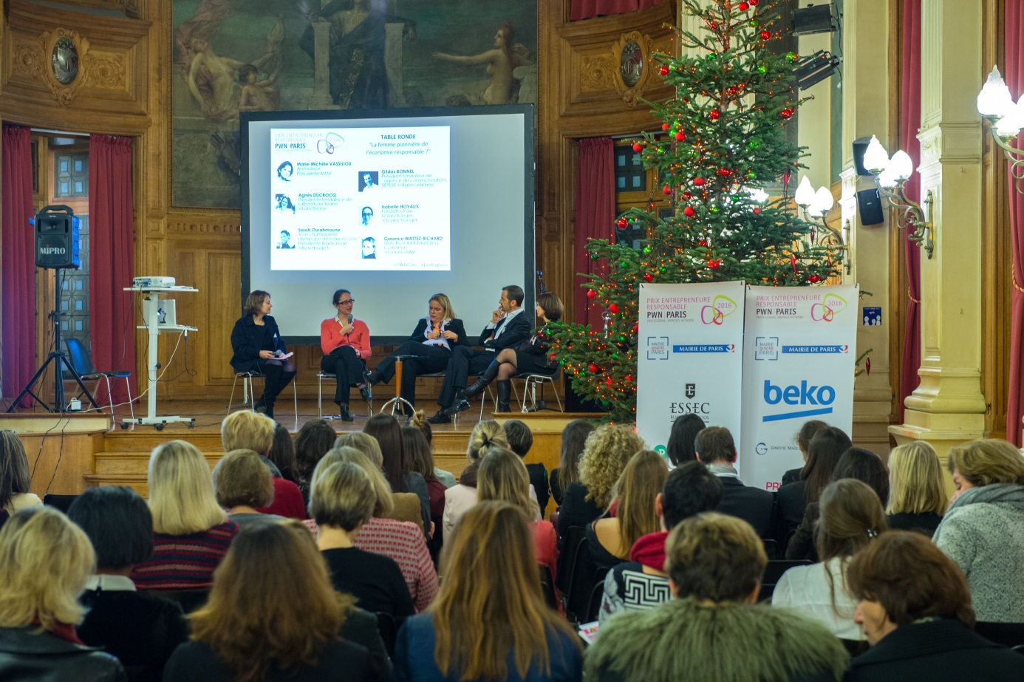

Our partnership has been promoted on all the communication tools of PWN Paris :
http://perbypwn.net/index.php/sponsors/

Twitter Facebook Linkedin

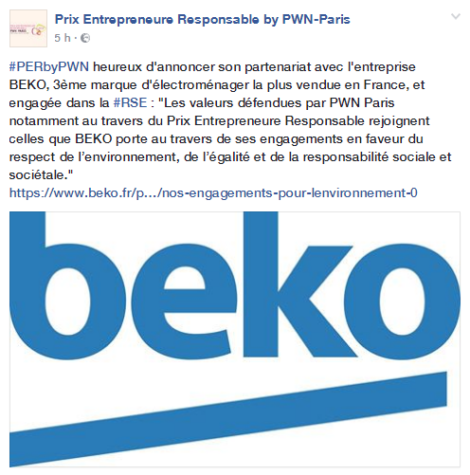

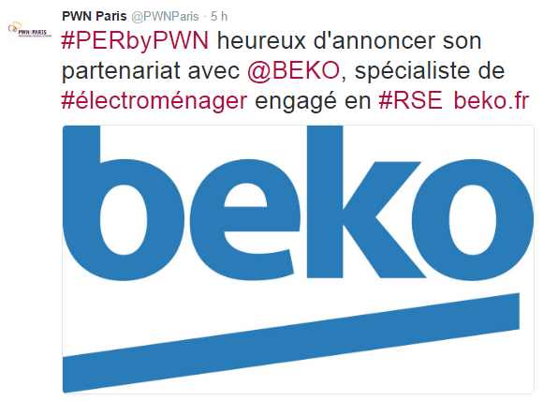

More information on beko.fr :

https://www.beko.fr/actualites-evenements/beko-partenaire-du-prix-entrepreneure-responsable-porte-par-pwn-paris

https://www.beko.fr/page-editoriale/beko-une-marque-socialement-responsable

