Martín Berasategui and Beko present the latest on cooking and washing

- The new Beko Surf oven allows cooking several dishes simultaneously thanks to Surf® technology.
- The model WMY121444LB1 includes the new ProSmart motor which offers 16 different washing programs
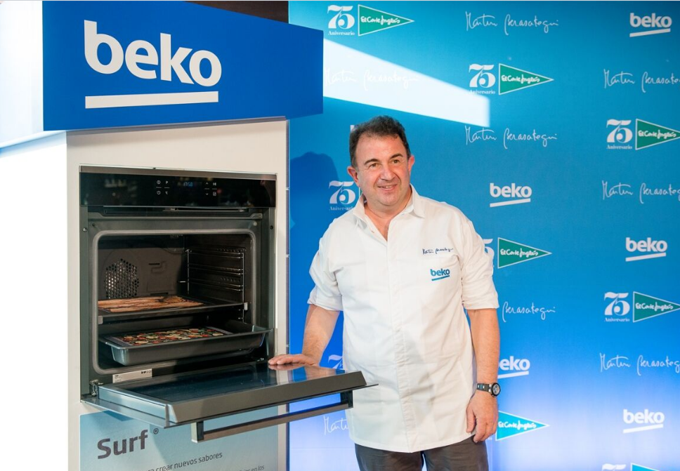

28 October, Madrid. – Beko, the international home appliances company which offers smart solutions for the Spanish homes, presents with the chef Martín Berasategui in El Corte Ingles of Callao (Madrid) a showing ‘Test Beko’ of the new ovens range with Surf® technology and the new washing machines range with Motor ProSmart Inverter.

In the meeting, Martín Berasategui, Beko ambassador, carried out a show in order to get more profitability to Beko products especially to the new Surf cooking system of the oven BIR15500GMS.

On the other hand, Beko presented the new washing range with the model WMY121444LB1 as protagonist.

Cem Akant, General Manager of Beko Spain, also attended the event and went along with Martín Berasategui who declared “Cooking simultaneously several recipes in the Beko ovens is a gift and the ProSmart washing machines allows me to be clean and ready in any moment”.

During the presentation, the attendants participated to the “Beko Test” and interacted with the Brand products with Berasategui who gave some tips in order to get more profit from the Beko appliances. He also signed aprons and delivered mini recipes books while enjoying a nice cocktail with Beko team.

Click to get the event pictures: https://goo.gl/GSlDXz

