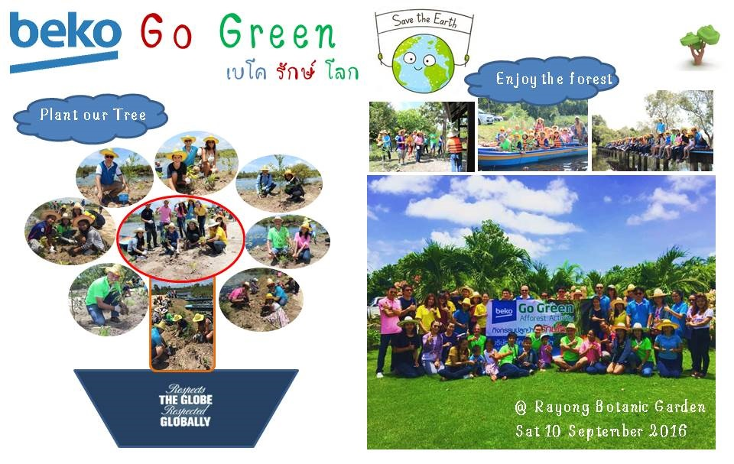
Beko Thai launched their first voluntary project “Beko Go Green” for ‘Respects the globe, respected globally’
The first “Beko Go Green” project is the afforest activity that held on September 10, 2016 at Rayong Botanic Garden. The employees can take their family to join the event.
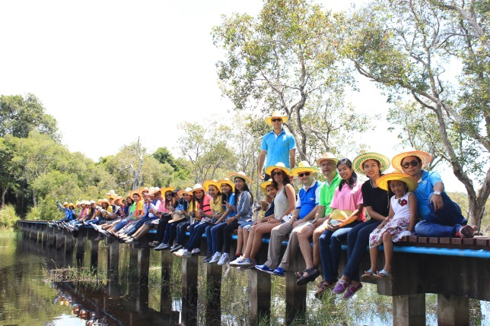
Know the idea
Everyone wish they could be Hero who take the action for Save the earth, for this activity we can be ourselves and be part of good things. Every voluntary event will be more effective when they can do with their love one like friends and family.
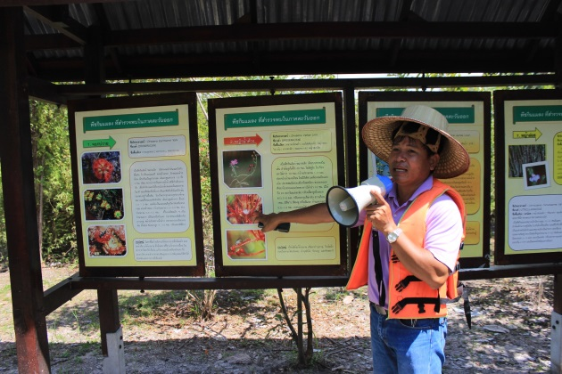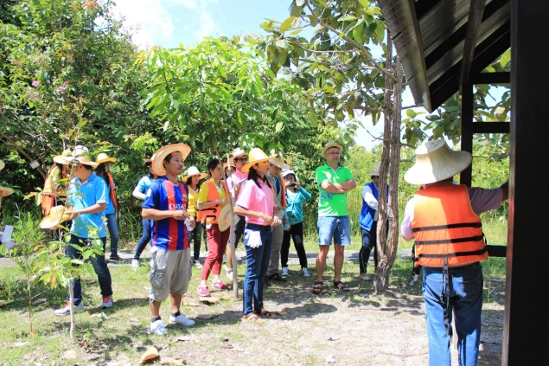
Know the place
Every volunteer attend the event which started with the Botanic Garden Rayong background training by Mr.Watchara Boonchai the Head of Botanical Garden Organization Rayong. The garden area is 477 Acre and being wetlands type.

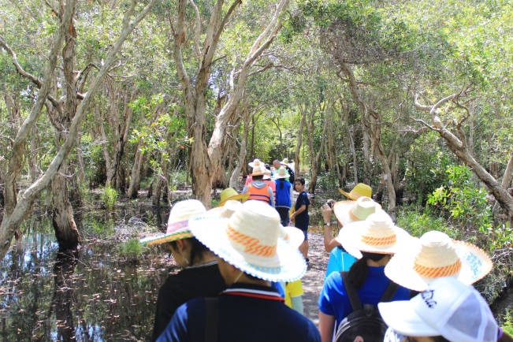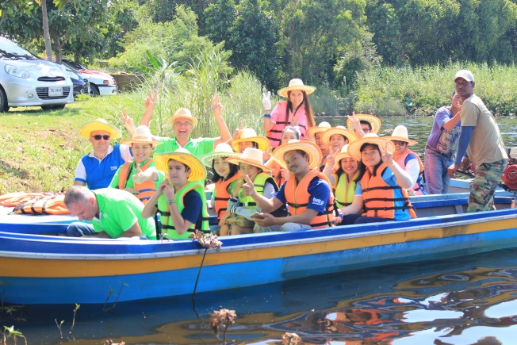
Know the forest
Most of the garden is the wetlands, the lands is being unique eco-systems among the most biologically diverse and productive. The focus on local plants (aqua plants) & herbs conservation

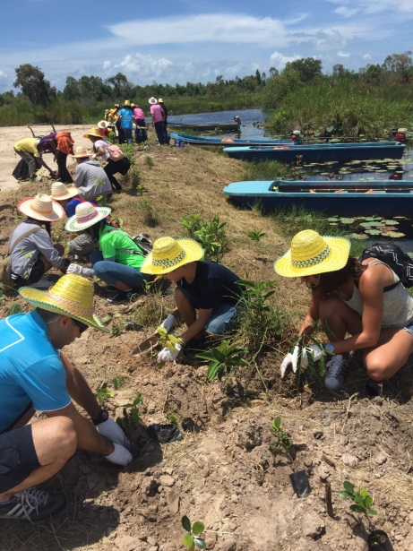
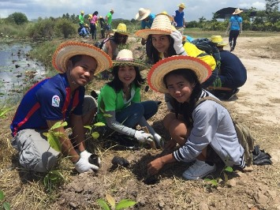
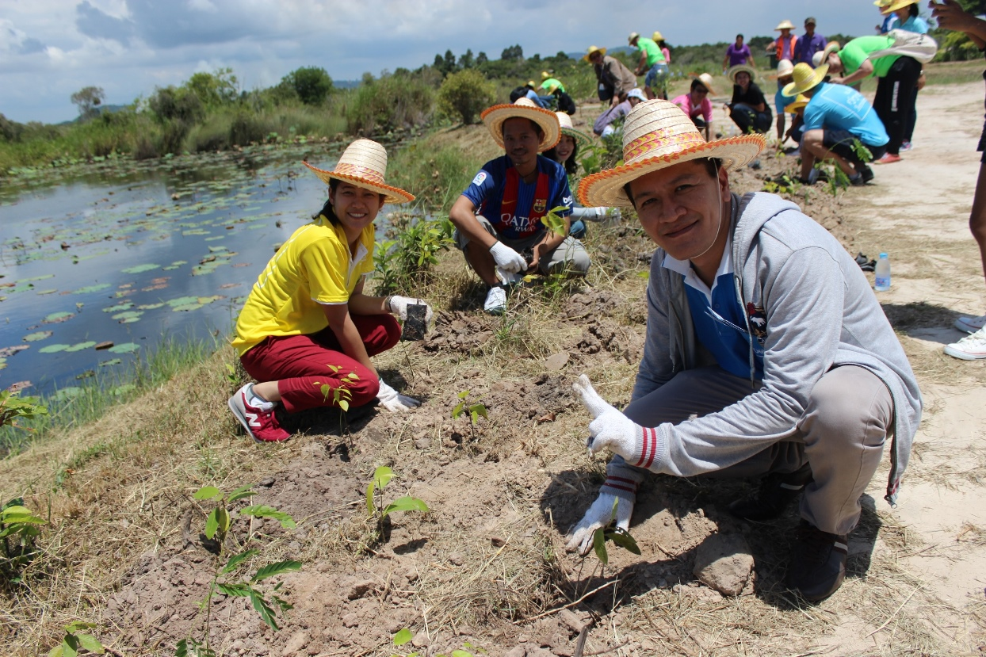
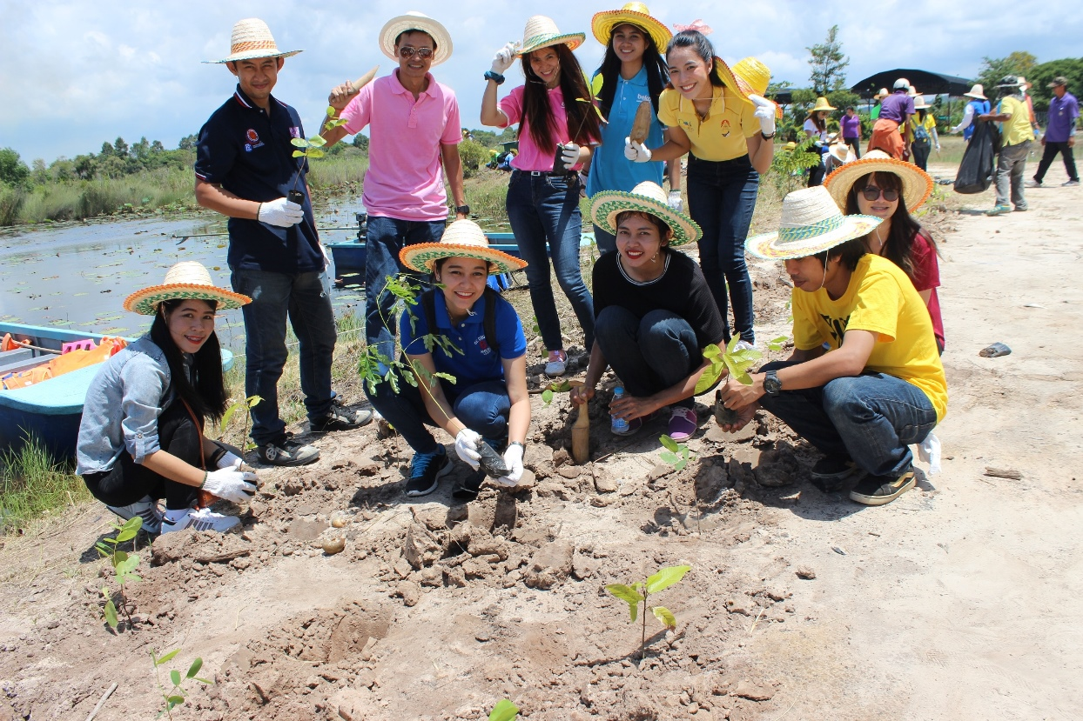

Know our passion
Thankfully for all volunteer who joined the event, everyone have plants their own trees, we finished the 300 planted that day. Under the sun and clearly sky, we know that this is our passion for save the Globe, we all “Save the earth”

