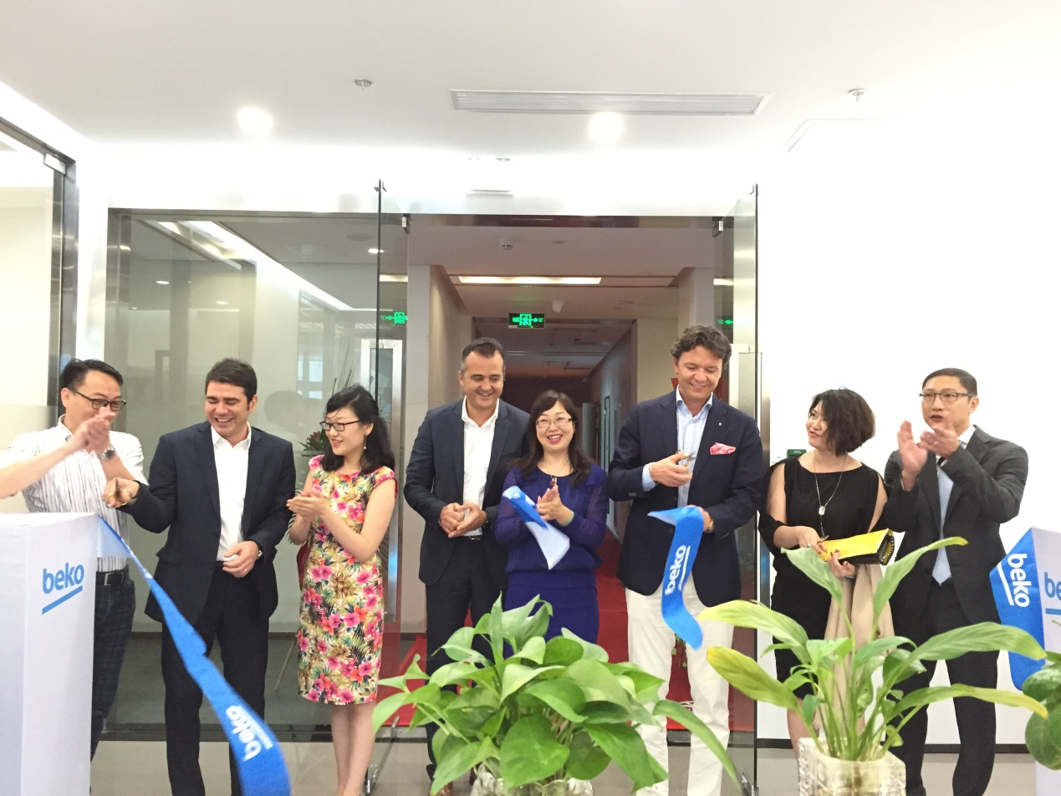
Home Appliance Giant Arçelik Expands its Global Sourcing Center
Jun 20th, Shenzen, China: Arçelik, a global player in home appliances industry, held a grand opening ceremony of its new global sourcing center. The company aims to further expand its operations in Chinese local market as well as support its global business.
Arcelik CEO, Hakan Bulgurlu attended the ceremony, which also hosted representatives of the company’s top suppliers in the region.
Delivering a speech at the ceremony, Hakan Bulgurlu said that, Arçelik has always considered China as one of its key markets. Since its establishment in 2011, Shenzhen sourcing center has gradually become a most important part of Arçelik’s global business and played significant role in the Group’s expansion in Far East. In addition to its sourcing activities, Shenzhen sourcing center also takes responsibilities on materials and components quality control, ensuring the finished product’s quality in Far-east market.
Considering Chinese market’s outstanding performance against the slow recovery of global economy, Arçelik’s new sourcing center is not only simple expansion of the company’s scale, but is also a solid proof of increased investments in supply chain.
Furthermore, in addition to its fundamental sourcing functions, the center has developed its R&D and industry design capabilities. In the near future Shenzhen sourcing center will be an integrated organization handling sourcing, quality control, R&D, industry design, manufacturing and sales. Arcelik will continuously optimize the center’s organization structure and improve its operation efficiency.
Hakan Bulgurlu also emphasized that Shenzhen sourcing center is targeting to double its annual business revenue to $400 million within next 5 years. By using the advantageous geographical location and governmental policies, Arcelik will continuously increase its sourcing scale from China and expand its business throughout Asia. Shenzhen sourcing center, as the most important part of this strategy, will be granted more duties and responsibilities. The Company will spread its arms to welcome the opportunities and challenges from China market.

