PRESS RELEASE

Grundig New Home Experience – greater variety and flexibility at home
Flexibility, at-home experiences and a premium product line-up are the focal points for the home electronics manufacturer in the new year.
Nuremberg, 19 January 2016: Grundig opened its annual kick-off presentation with a look at its strategy as a premium home electronics manufacturer and set the agenda for 2016. The company aims to sustainably secure its market position through a high level of innovative power and a product range that not only provides entertainment, but also captures customers’ imaginations – and most importantly, brings that experience into their homes. The Grundig New Home Experience brings together the brand and its product ranges to form a dynamic, efficient and connected company identity in 2016.
Consistently expanding smart home electronics
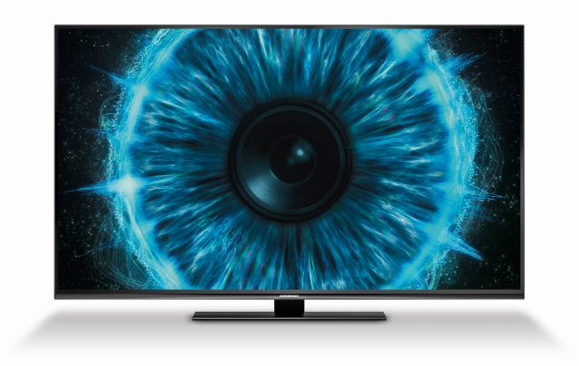
Grundig’s new Immensa TV range will create a New Home Experience (© Grundig Intermedia GmbH)
For Sühel Semerci, the new Managing Director of Grundig Intermedia GmbH since 15 January, the task is to systematically move Grundig forward and further expand the smart factor in the company’s home electronics range. In Nuremberg, he expressly thanked Murat Sahin: “Mr Sahin made a deep impression on the Grundig brand and the company through his great dedication over the last four years. His main achievements were Grundig’s growth in Germany and the whole northern Europe region as well as the expansion of the portfolio to over 500 products encompassing all areas of home electronics.” Grundig’s transition to a smart home electronics manufacturer is something that Semerci believes is closely linked to the brand’s traditional values and timeless design. “We will continue down this path in a systematic manner and also prioritise it at an international level,” Semerci said.
With the anniversary year behind it, Grundig plans to utilise its positive brand perception as it enters the UEFA European Championship year. “Our goal is to turn challenging industry conditions around in a positive direction and solidify our market position as a home electronics manufacturer with smart products, to sustainably position ourselves in the trend segments in our four business areas and capture customers’ imaginations with solutions for every room of the home. To do this, we’re building on our close ties to retailers as well as our strong brand.”
Market share increases again
Horst Nikolaus, Managing Director Sales, Grundig Intermedia GmbH, adds: “Grundig was unable to completely avoid the developments and decreasing sales figures brought about by a difficult overall TV market in 2015. However, our development was stronger than that of the overall market, and the current market figures at the start of the year give us new impetus for 2016. We are very satisfied with business development in the sound and small appliance areas, where we further expanded our distribution network and benefited from our new products and the highly attractive Grundig brand.” Grundig sees its close cooperation with its retail partners in particular as the basis for a successful year: “Our even closer cooperation with retailers in 2015 will give us strength and stamina for 2016. By the end of the year, we want to further expand our market position when it comes to sales figures in the TV segment.” With campaigns perfectly tailored to retailers as part of the Grundig POS+ initiative, the company also intends to continue working closely with its partners in 2016: “We would like to incorporate retailers’ market requirements into our planning process to an even greater degree through communication on an equal footing, which will also help us to pick up on growing trends and offer marketing concepts that will ensure that we achieve success together.”
Premium products for the New Home Experience
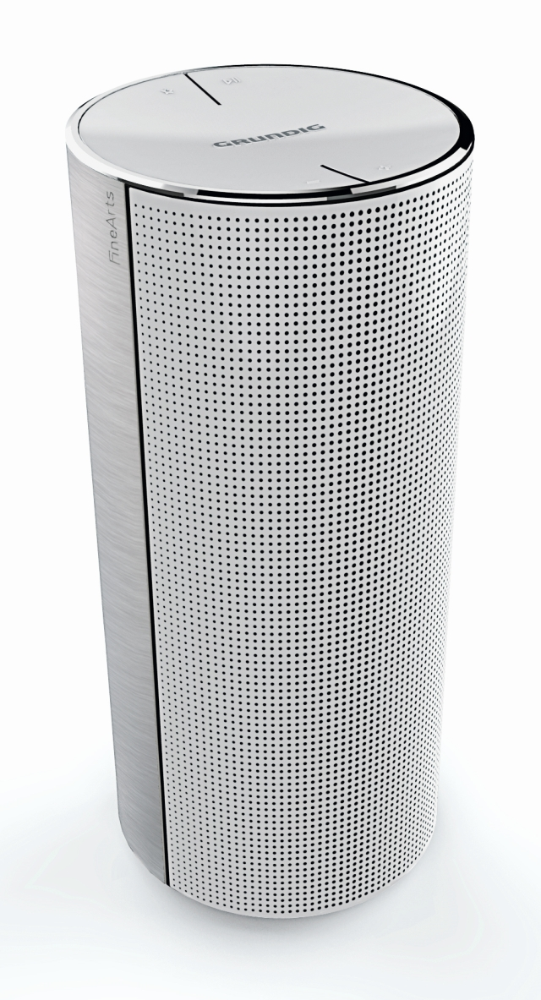
Connectivity: Grundig’s Fine Arts Multiroom Speakers ensure top entertainment in every room of the home (© Grundig Intermedia GmbH)
The marketing strategy for 2016 centres on the Grundig New Home Experience as a brand promise that encompasses a comprehensive product range with over 500 products in three business areas: to bring exciting products to every room in the home and to convey the changing and dynamic world of today. The new products, such as the state-of-the-art Immensa TV range, give a taste of Grundig’s highlights for the UEFA European Championship year. With 22 new products as part of the Vision 7, Vision 8 and Vision 9 lines, from Full HD to Ultra HD, Grundig is expanding its TV range with the latest technologies to bring top picture and sound quality straight to customers’ homes. High Dynamic Range, Multi Color Enrichment and Grundig’s Micro and Local Dimming Engines, as well as three-way stereo sound and the DTS StudioSound HD technology, ensure top picture and sound quality and perfect reception. Last but not least, the 360° Panorama Design enhances the premium promise of the new device range.
With connected audio solutions, such as the Grundig Multiroom Speakers, Grundig is also introducing the forerunners of the flexible and expandable Fine Arts series network hi-fi system. Elegant design structures with elements made of high-quality brushed aluminium and an impressive stereo sound system featuring 40 watts of RMS power, bass reflex system and two subwoofers and tweeters will bring the Grundig New Home Experience to every room of the house. Comprehensive connectivity options via Wi-Fi, WiFi Direct and Bluetooth enable a flexible, expandable system with up to 30 units in one home. One particularly practical and highly flexible feature is that the speakers can be moved quickly from one room to another thanks to the docking station and rechargeable battery, which can provide top-quality sound for four hours.
The New Home Experience also includes innovative features for Grundig’s latest large home appliances, such as the efficient refrigeration solutions offered by the GSBS 15721 FX Side by Side combi fridge freezer. This fridge freezer features the FullFresh+ function, which brings cool air through small ventilation holes in the vegetable drawer, creating ideal conditions for fruit and vegetables by maintaining a consistent temperature and ensuring high humidity. The new GTA 38267 G hybrid tumble dryers also enables greater efficiency when it comes to housework. The ExpressDry technology can dry 8 kg of clothes in 115 minutes.

About Grundig Intermedia
Grundig Intermedia is one of the leading suppliers of consumer electronics and small and large household appliances. With a portfolio of more than 500 different products – ranging from Ultra HD TVs, mobile audio devices, hair styling devices, vacuum cleaners and kitchen appliances to ovens, dishwashers and washing machines – the brand offers a solution for every room in the modern home. As a European full-range manufacturer, Grundig continuously sets new standards with its home electronics products in terms of quality, design and innovation. Grundig is a part of Arçelik A.S., the third largest company in white goods industry in Europe and belongs to the listed Koç Holding, a global conglomerate with more than 80,000 employees. Worldwide, more than 1,000 people work in R&D to design and manufacture pioneering and environmentally-friendly products. Grundig’s Marketing, Sales, Product and Quality Management, Logistics and Service divisions for the German market are located in the Langwasser district of Nuremberg, Germany. Grundig manufacturing plants are located in various locations all around Europe delivering Grundig products to more than 55 countries worldwide. Learn more at www.grundig.com.

