Beko delivers speed in its most gentle form with NEW AquaTechTM technology

New AquaTechTM washing machine harnesses the power of water to create a gentle cycle that provides effective cleaning, even at low temperatures

Always on the lookout for ways to make customers’ lives easier, Beko, Europe’s No.1 freestanding home appliances brand, has today announced the launch of its AquaTechTM technology washing machine at IFA in Berlin.

The new AquaTechTM washing machine harnesses the natural power of water to create a gentle yet effective cycle, replacing standard tumble moves with more movement of water inside the drum.

Featuring up to a 50% faster cycle time but without compromising on effective cleaning, the innovative AquaTechTM technology washing machine is set to give back precious hours to anyone who does laundry at home by offering smarter, shorter programs for greater convenience.

Consumer insight revealed a preference for delicate washing even at lower temperatures, as well as opting for faster cycles to save time. While this approach with standard washing machines can compromise the cleaning efficacy required, thanks to AquaTechTM, Beko is able to offer spin cycles that work both quickly and effectively, whilst preventing any damage to textiles. It means households around the world can benefit from a more convenient approach to their laundry.

The innovative AquaTechTM technology works by optimising the power of water circulation to ensure more efficient wetting of garments and a more thorough clean as a result. The internal sensor ensures that the paddle is positioned at the top of the cycle, which then showers the contents of the washing machine with the detergent and water mix. The wearing mechanism typically found in standard washing machines has been replaced by water power, enabling clothes to be washed quickly, thoroughly and gently.

Providing a faster and more convenient washing cycle, speed is delivered in its most gentle and effective form.

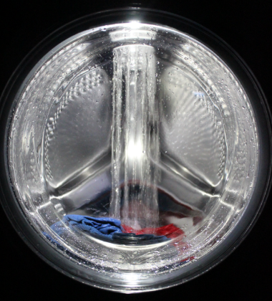
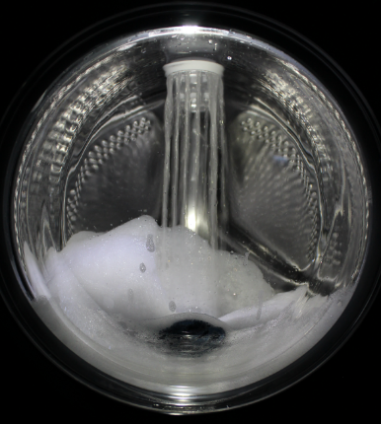

The AquaTechTM technology washing machine will be available in from March 2019. For more information, visit www.beko.com.

- Ends -

Notes to Editors

Product Features
AquaTechTM Washing Technology
- Up to 50% faster programmes
- Up to 30% more gentle
- All programmes last less than two hours

About Beko:
Beko is number 1 brand in the European free-standing white goods market and the second largest home appliances brand in Europe (Dec, 2017). It has been the fastest growing major home appliances brand in the overall European market since 2000. Beko is the international home appliance brand of Arçelik and a Premium Partner of FC Barcelona.

For more information or imagery, please contact:

Kate Howarth Isobel Knight
Kate.Howarth@mslgroup.com Isobel.knight@mslgroup.com
+44 7974 264551 +44 7834 587675

