Grundig is raising awareness on global food waste with Respect Food initiative
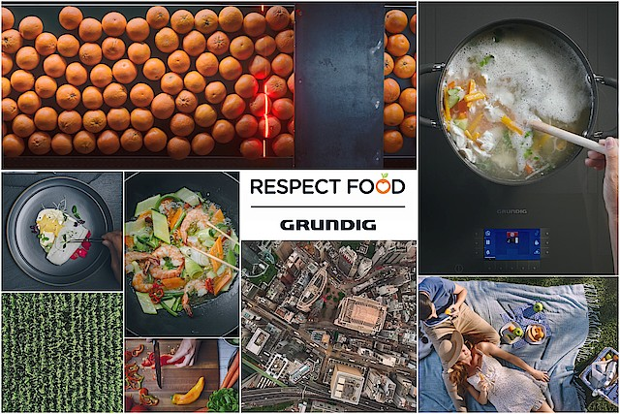

Grundig is proud to announce Respect Food's global launch, aired on World Food Day, 16th of October.

Following the launch of the brand’s new communication platform "Where Home Is", “Respect Food" initiative indicates a higher cause and fulfills Grundig’s brand story. "We're making homes the best places to be while making the world a better place"

As a global brand with eco-consciousness, Grundig champions the cause of reducing the food waste and inspires everyone to tackle waste in their kitchens with innovative technologies. The message “wasting food is wasting life” is delivered in a powerful way. In just one week the film has been watched 9 million times, with a record view rate of 53%.

Please enjoy Grundig’s manifesto film here

Respectfood.com is designed as the initiative’s public platform to guide on how to tackle food waste and inspire the society with the tips&tricks, recipes and innovative solutions to support the movement.

Respecting Food is the only way to make our earth the best home to be.
Let’s #respectfood and make the earth the best place for everyone.

