**Beko Launches New Assembly Plant in Ethiopia**

**October, 2017**

The South African Beko Exports team is proud to announce the opening of the first Beko SKD (Semi Knock Down) assembly plant in Ethiopia with the support of our distributor (Al-Sam PLC). The SKD plant forms part of our long term strategic planning in boosting revenue and local market growth of Beko. This project is the result of close collaboration with our distributor. The production plant is a strategic tool that will create jobs and opportunities for the people of Ethiopia. In addition, this project will result in an increase in market share and provide the opportunity to deliver products in a cost effective manner according to regional preferences.

The SKD plant consists of two assembly lines that will assemble refrigerators, chest freezers, cookers and built-in oven products. The product line up will be supported from all Arçelik factories. A television line will be introduced in the first quarter of 2018, ranging from 24 to 55 inch panels.

Beko is currently also in the process of establishing a television and air conditioner assembly plant in the first quarter of 2018 in Nigeria.

By the first quarter of 2018, Beko will have a total of 9 active assembly lines in Central Africa Region.

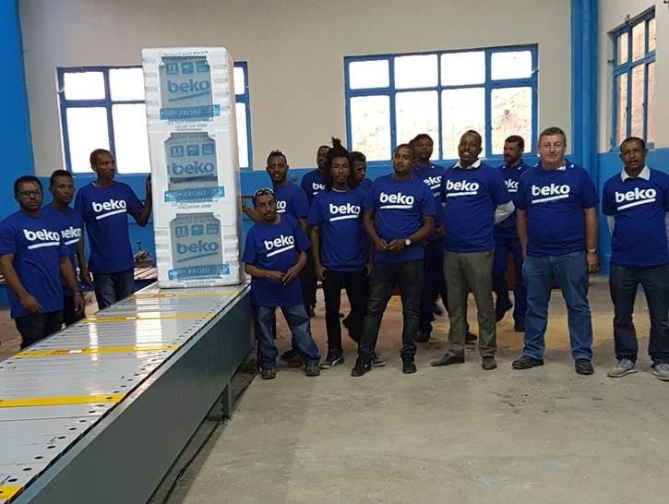

DEFY’s first refrigerator and chest freezer in SKD format was assembled in Ethiopia under the Beko brand.