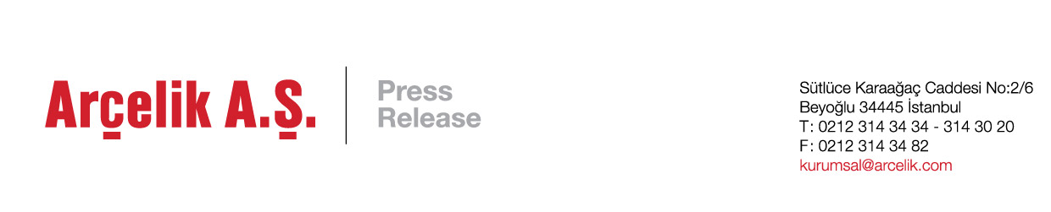

Arçelik A.Ş. heralded as corporate responsibility leader in prestigious European Supply Management Awards

Arçelik A.Ş. named winner for ‘Best Contribution to Corporate Responsibility’ in 2017 European Chartered Institute of Procurement and Supply Management Awards.

Istanbul, 20 October 2017: Arçelik A.Ş., leading global household appliances manufacturer and mother company of Beko and Grundig, is honored to announce their recent award for ‘Best Contribution to Corporate Responsibility’ in the 2017 European Supply Management Awards, organized by Chartered Institute of Procurement and Supply (CIPS) and ProcureCon.

With sustainability at the heart of the company, Arçelik’s award recognizes the company’s ongoing work with suppliers in improving its transparency and sustainability across its supply chain through it’s innovative ‘Transparency in Business’ training programme. The programme, which was rolled out over 2015 and 2016, provides Arçelik’s suppliers with training, coaching and development in sustainability reporting, and certification across social, environmental, human rights and ethical issues.

By empowering and equipping their suppliers with the expertise to be more sustainable, Arçelik has not only seen social benefits for the company and their suppliers, but also become more financially competitive in its main export markets in Europe and the United States.

Arçelik’s recognition in the recent CIPS awards continues to solidify the company’s reputation as a sustainability leader, after the company become the first-ever Turkish manufacturing company to join the Dow Jones Sustainability Emerging Markets Index last month.

The CIPS Supply Management Awards Europe in association with ProcureCon Europe, is respected benchmark of excellence within the procurement and supply chain professions. With the categories covering the full breath of the procurement field, including corporate responsibility, people development and supplier relationships.

Commenting on the award, Polat Şen, Arçelik A.Ş. CFO said: “We’re honored to receive the prestigious CIPS Supply Management Award recognizing our on-going work with our suppliers to uphold the sustainability values we embody as a company. At Arçelik we’re proud to be an industry leader in embedding sustainability throughout our entire value chain. This commitment reinforces our position as a responsible business, encouraging our supply chain to stimulate innovation and enhance their competitive advantage.

ENDS

About Arçelik A.Ş.: Arçelik A.Ş., part of a leading conglomerate Koç Holding, offers products and services in 145 countries with its 30,000 employees, 18 production facilities in 7 countries (Turkey, Romania, Russia, China, South Africa, Thailand and Pakistan), its 34 sales and marketing offices in 32 countries and its 11 brands including Arçelik, Beko, Grundig, Blomberg, ElektraBregenz, Arctic, Leisure, Flavel, Defy, Altus and Dawlance. As the third largest home appliances company in Europe, the consolidated turnover of Arçelik A.Ş. was totalled at TRY 16.1 billion in 2016. Generating 60% of its income from global markets Arçelik A.Ş. owns 14 R&D centres, employing over 1,300 employees. Arçelik is listed in ISE (Borsa Istanbul) since 1986.

About Chartered Institute of Procurement & Supply (CIPS): CIPS is a United Kingdom-based global professional body working for the purchasing and supply professions. With an objective of "leading excellence in procurement and supply", it aims to promote good practice and provides services for the benefit of a procurement community of 115,000 members. CIPS aims to promote and develop high standards of professional skill, ability, and integrity among all those engaged in purchasing and supply chain management.

About ProcureCon: A part of the World Business Research, The ProcureCon event series brings together a unique blend of Procurement, Purchasing and Supply Chain experts from across all industries to share their experiences and knowledge with a team of people who truly embrace the strategically important field of Procurement. Founded back in 1996, Worldwide Business Research launched with 12 events in its first year.

