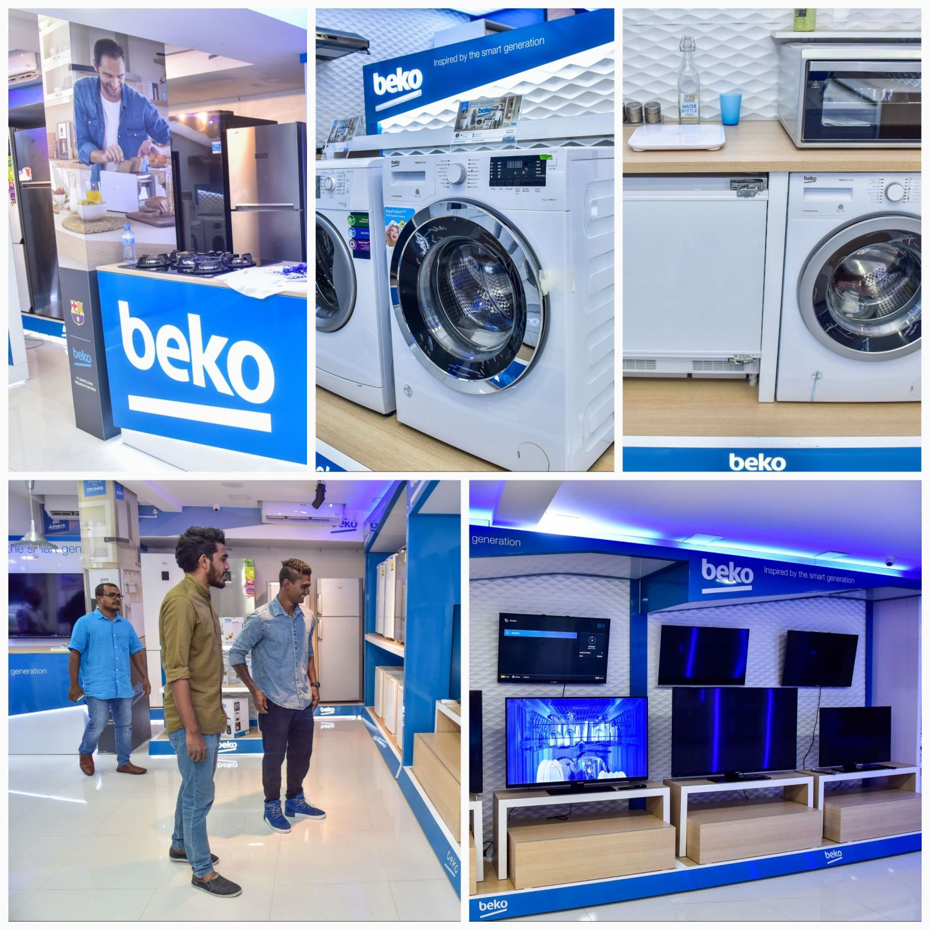

The 1st Beko Showroom Opens in Maldives!

The first Beko showroom in the Maldives has been opened by the support of Beko Near East Marketing & Sales team and Faza Holding, the distributor in the Maldives. Beko products took their places in exclusive floor dedicated only for Beko.

The invitees including socialites, celebrities and company staff gave close attention to the wide range of Beko products at the opening organized on July 13.
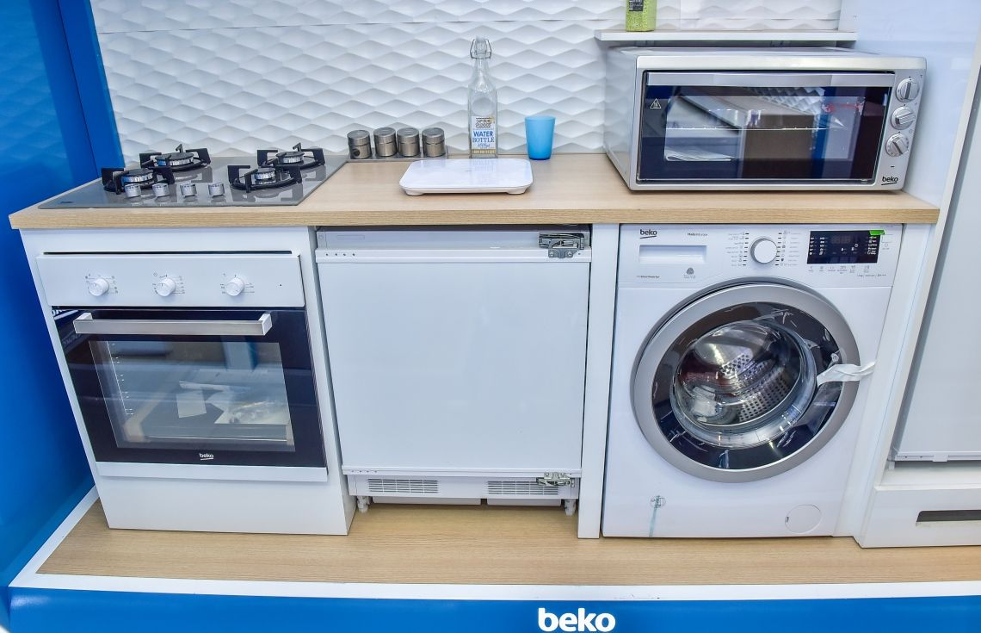

Maldivian Olympic Athlete Mr. Hassan Saaidh, who won numerous awards in international tournaments, was also among the guests of the opening.

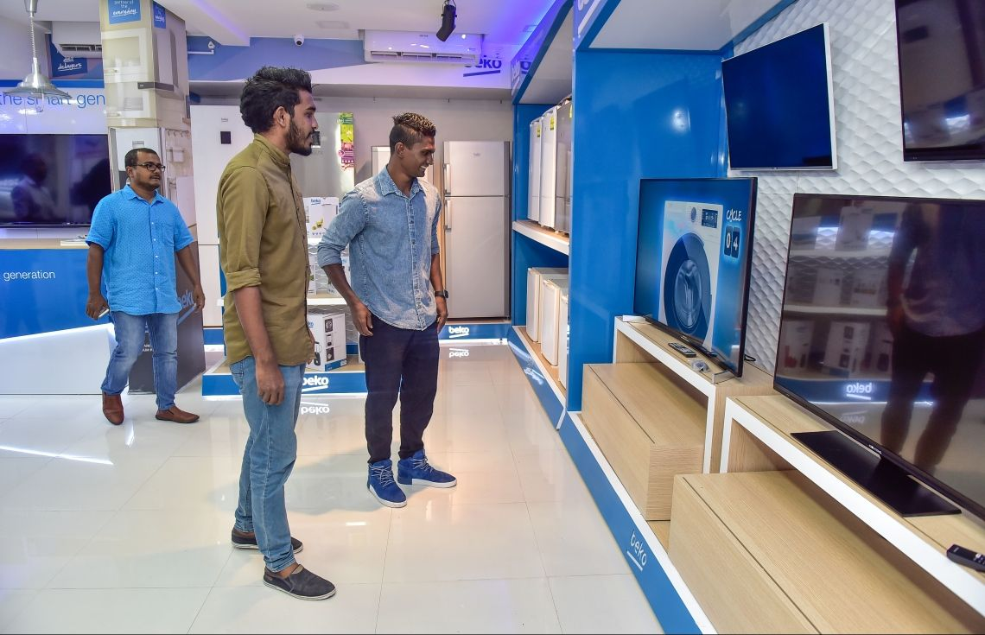

Hassan Saaidh is known with his popularity among the country due to his success in South Asian Games in 2016.

Beko marketing & sales team plans to have additional events to draw more attention by the visitors and local population of the Maldives in the upcoming months with the help of Faza Holding.

