Grundig Makes Homes the Best Place to Be

Grundig has launched a new brand film to highlight its new brand claim ‘Where Home Is’.

Based on the insight that ‘Home makes us feel good and safe’ the new brand film highlights the anticipation of reaching home and simple joy of being in one’s own space.

As one of the biggest full-range suppliers of home electronics in Europe, Grundig will now celebrate and own the emotional significance of ‘home’, and build a powerful message that ‘Making your home the best place to be.’

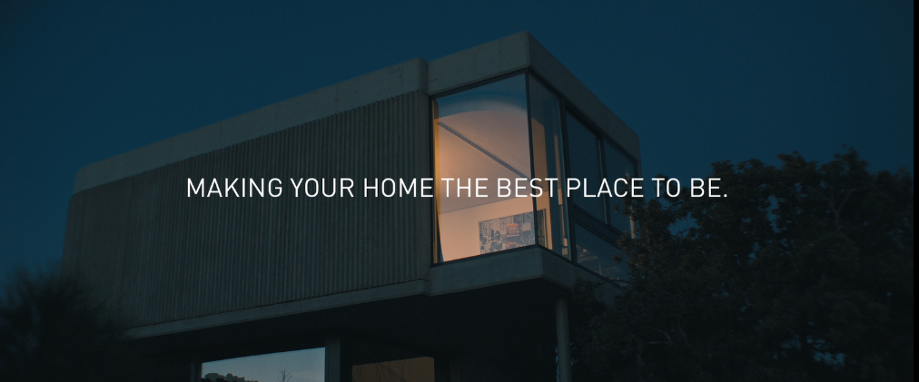

The film was shot by director Marco Gentile in Madrid. The shootings took three days in various stages to appreciate the meaning of home and highlight Grundig’s role to make this precious venue even better.

Aim to increase MDA awareness, launch is planned for 18 countries with an integrated communication plan. Just two weeks after the launch, the campaign reached more than 27 million impressions and the view rate is 41% which is far beyond the benchmark 15-20%.

Enjoy the film: https://www.youtube.com/watch?v=0eqr9-Mfz7I

