THAILAND FACTORY MADE ITS FIRST REFRIGERATOR PRODUCTION
The first refrigerator was produced at December 24, 2015 as planned in Thailand Factory where the Groundbreaking Ceremony was held in this year.
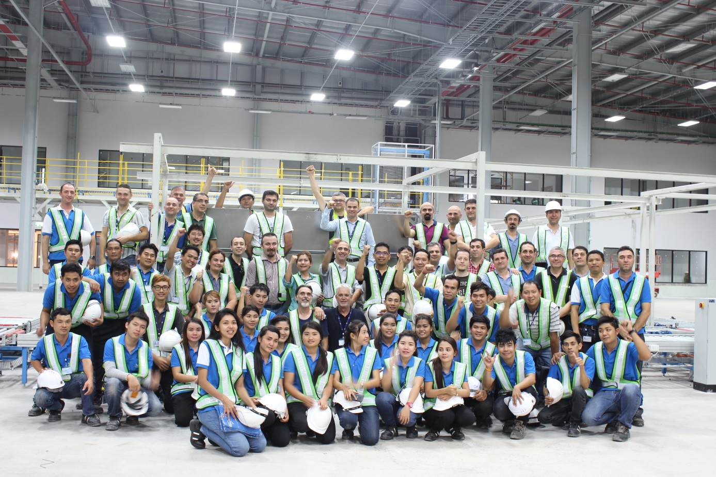
After the piling operation for strengthening the land, construction of the factory was started at the beginning of June. After finishing MEP infrastructure project in factory area, installation of production equipments, completion of the mold production and commissioning of local suppliers; the first trial production was done on the factory’s assembly line 7 months after the start of construction.
Thailand Factory, totally 263.000 m² of land with a closed area of 42.000 m², has a capacity of 300.000 pieces/year for the first year. Factory investment plan was done for the future high quantitiy demands with an additional equipment installation plan and extension project of the current factory building.
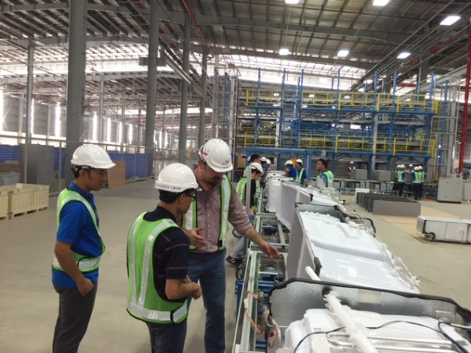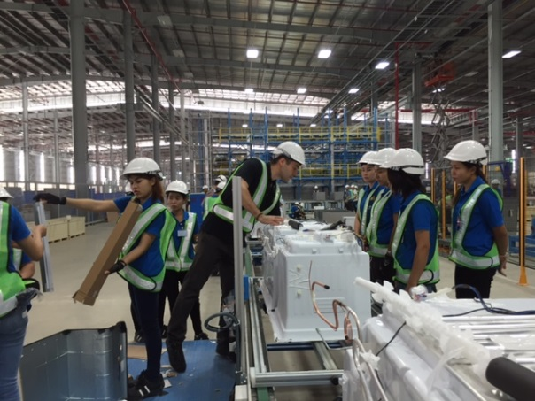
Operator training that is necessary for the implementation of production systems began in Eskişehir Refrigerator Factory and continues in Thailand with the help of Arcelik engineers.
Thailand refrigerator factory’s products have been specifically designed in accordance with the requirements of the customer needs and competitiveness in Southeast Asia market. 10 different models were designed in 2015 and will be commissioned according to the project schedule.

